Weekly Work Report 11/22/2024

**This Week:**

**Put feedback on the top**

* **Data Processing:**
  + Completed Empatica data processing.
  + Preprocessed EEG signals for 80 subjects. (62)

.csv files in this archive are in the following format:

* The first row is the initial time of the session expressed as unix **timestamp** in UTC.
* The second row is the **sample rate** expressed in Hz.

* **Feature extraction**

Converted EEG signals into 2D spectrogram images and extracted spectrogram features. (2D CNN)

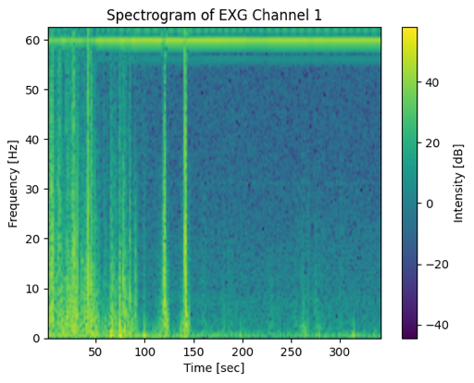

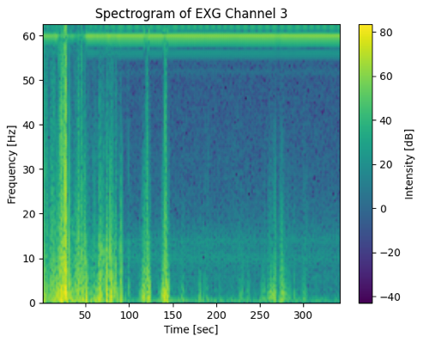

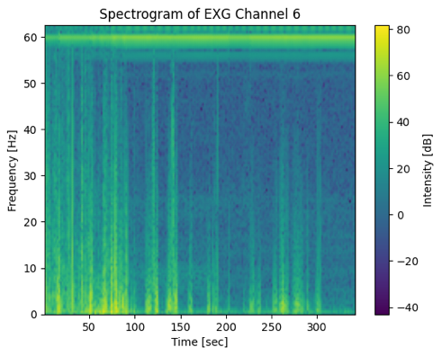

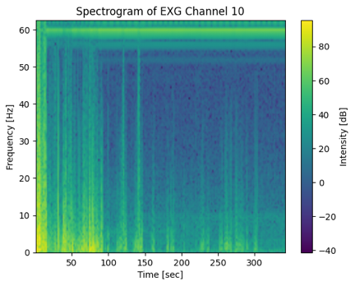

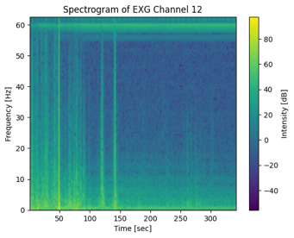

**Next Week:**

* Complete processing of additional signals, including **pupil** data.
* Train models using **spectrogram** features.

Table:

* Features, models
* Compare Result

Plot:

* ROC Curve (3)
  + Avg
  + Combine them together, confusion matrix
* Imbalance ROC Curve, (1 vs others)

**Short-term Goal:**

* Compare Aha!/Impasse/Attention classification using
  + physiology signals
  + EEG
  + physiology signals + EEG

**Final Goal:**

* Explore the dynamics of **Attention**, **Impasse**, and the **"Aha!"** moment.
* **Attention:** high, low
* **Impasse:** yes, no
* **"Aha!":** yes, no